Differences Between Medieval and Byzantine Arts
Student’s Name
Institutional Affiliation

Medieval art is represented in many ways, and it was continually advanced during medieval times. The emergence of the Pre-Renaissance period influenced the advancements that were witnessed during medieval times. The earlier subjects of this Pre-Renaissance period were restricted to religious works of art, which were referred to as the Pietistic paintings. These religious artworks came various varieties like illuminated manuscripts, fresco painting, and the mosaics, which could be found in churches. Due to the different forms that the medieval arts came in, historians came up with ways and decided to formulate ways in which they can specify these different forms of medieval arts. The first way that they used was the classification according to the significant periods of the different middle ages and their styles. The medieval art was classified into Byzantine art, Christian art, Migration Period art, Pre, Romanesque art, and Gothic art. Besides, other classifications were based on the cultures of the individual nations that had distinctive styles. Therefore, the primary classification of the medieval arts that brought about the different forms of art was based on different characteristic stylistic features that were used in the classification of the artwork.
Medieval art had its distinct color that was used in its classification. Medieval art had a remarkable distinct color that was used as a characteristic feature for its classification. Most of the artworks from the medieval period did not utilize perspective, and thus, the figures would convey distinct emotions. Majority of the historical scholars stipulate that pieces from the medieval period show essential figures, and the figures appeared to be more significant as compared to other figures that surrounded the arts. From this description, distinct characteristics associated with medieval art can be formulated. The historical Middle Ages stretched from the time when Roman Empire fell to the beginning of Renaissance period and thus a number of the pieces of art that were produced during this period were meant for the church. The artworks at this time were meant to glorify God instead of their aesthetic appeal.
Additionally, an extra characteristic feature of the medieval art is its revolving focus around holy families as well as the saints. However, despite the majority of medieval art focusing on the glory of God, some paintings and sculptures made war depictions. For instance, Roman de la Rose was one of the medieval artwork that most people associated with cathedrals, manuscripts, feudalism, and monks.
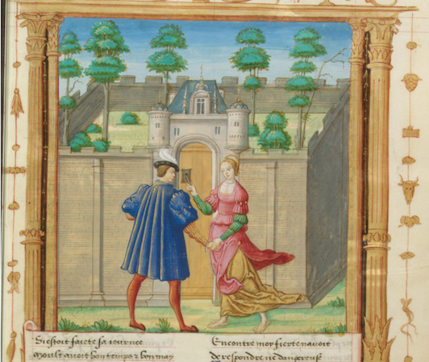
The sculpture is one of the medieval art that represented love. The Lover was speaking to idleness-lover, where they extended arms representing the personification of the idle. The actions that are depicted from the painting illustrate idleness where the two were holding hands without doing anything other than placing the keyholes in the door.
Byzantine art is one of the medieval arts that demonstrated dedicated and extremely styles that were conservative. Majority of the pieces from the Byzantine art stuck to the styles of the simplified Greek stylization of figures. The vanity disdains of the Byzantine arts made it possible for the use of the simplified stylization and the attempts they made to demonstrate their nature of spirit subject. The art of Byzantine art originated from Byzantium, which was by then the Roman Empire capital. During the time art of Byzantine in the Roman Empire, the region was divided into two subsections; the western part and the eastern part. Later, at the fall of the Roman Empire, the western part was dissolved, as the eastern part remained intact. The religion of the Catholic as well as the Byzantine art pieces reflect the differences that exist between the two. The styles of the Byzantium art at the Dark Age period alongside the artwork that existed during medieval early period were developed for purposes of the Orthodox Church. Majority of the art pieces at this time were flat, and a number of them were one-dimensional and had no perspective. Artists who created this art did not incorporate shadows, and the figures faced the front.
Additionally, Byzantine art was characteristic of long and narrow faces that did not portray any realism in them. Byzantium art never comprised of any sculpture as they were considered to be a part of idolatry. Most of the artists who made this type of Byzantium art were adherents of the religious configurations and as were affiliated to monasteries. An example of the Byzantium art included the Rose windows that were used in churches. 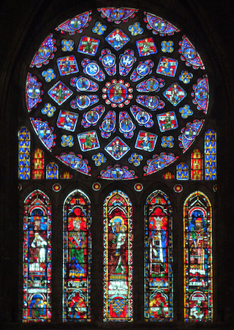
In the present day, Medieval stained glasses windows represent beauty aspects in church, but from history, medieval view of windows with stained glass were considered as books in Gothic Cathedrals. The medieval view, each stained pane contained a specific story, and each window was a representation of a book with stories, and the stories usually pertained to the Bible. However, some of the stains on the windows made references to other aspects like history, rulers of the past, and the present as well as seasons. The paintings were called rose windows because of the radiant glass towards the outside in circular patterns that resembled roses. Gothic Cathedrals contain most of these rose windows. Despite the illiteracy from the medieval times, there exists more considerable significance on the symbols that are placed on art like on the rose window. For instance, the rose window contained specific numbers, with distinct colors and objects, which elucidated different stories to the viewers. The rose window contains five circles, which as well contained twelve smaller windows. The center of the window contains twelve small circles with whom twelve windows radiate out of and they have twelve diamond shapes, which as well have twelve quatrefoils. Everything that art presented in the medieval period was planned. The inclusion of number twelve in the rose window was as well substantial.
Medieval art was different from country to country. For instance, the way medieval art was represented in England was different from the way it did in Europe. In England, medieval art decorated the stone buildings all over the nation. Traditions of culture with increasing native creativity formed the earlier English style. The medieval European art was regarded to as western art. The western has been the influencer of the world from the third millennium up to the present day. In Europe, medieval art was separated into distinct periods, with every period containing art that established what it was living in every distinct period. Every period of art was shaped by different characteristics that the medieval artists decided to incorporate in their art. Different periods of living displayed different styles with distinct characteristics. Therefore, from the analytical study of the different medieval arts, we can establish the differences in living in different periods.

References
Dr. Nancy Ross, "Introduction to the Middle Ages," in Smarthistory, August 8, 2015, accessed July 14, 2019, https://smarthistory.org/introduction-to-the-middle-ages/.
Stokstad, M., Cothren, M. W., & Asher, F. M. (1999). Art history. HN Abrams.
Stokstad, M. (2018). Medieval art. Routledge.

